JOBSHEET 9
ARRAY 1

- Objective
- Students are able to understand one-dimensional Array creation and accessing its elements in Java
- Students are able to make programs using the concept of one-dimensional arrays

Laboratory
  - Experiment 1: Fill in Array Element Experiment Time: 20 minutes
    - Open a text editor, create a new Java class with the name arrayNumbersXX. (XX=student ID number)
    - Write the basic structure of the Java programming language which contains the main()
function
    - Create an array of integer type named num with a capacity of 4 elements
    - Fill each element of the array with numbers 5, 12, 7, 20
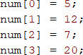
    - Display all contents of the elements to the screen
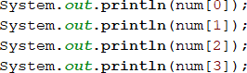
    - Compile and run the program. Match the results of the running programs that you have created according to the following display

    - Commit and push the changes to GitHub.
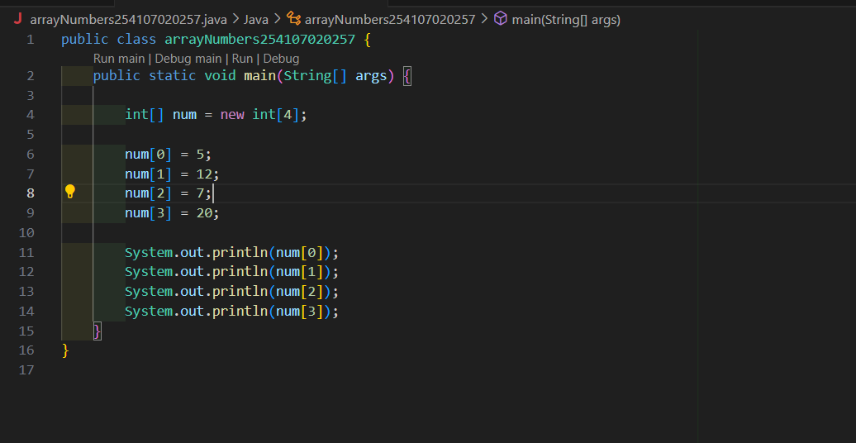

Questions!
- If the contents of each element of the array num are changed with numbers 5.0, 12867, 7.5, 2000000. What happens? How can it be like that?
So if 5.0, 12867, 7.5, 2000000 ussing array will be Decimal numbers (double) cannot go into int.
- Modify the program code by initializing the array elements at the same time when declaring the array
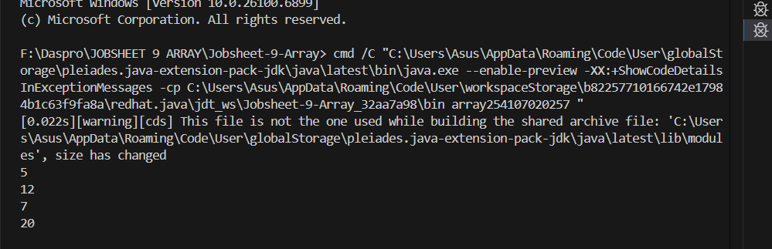
- Modify the program code by initializing the array elements at the same time when declaring the array.
- Change the statement in step 6 to be like this
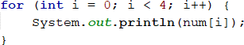
What is the result? How can it be like that?
So the result changes because the the first one prints the array’s memory location, while the second on the prints the array’s elements- to the Array.toString() method that converts it to a human-readable form.

- If the condition in the for-loop statement is changed to i <= 4, what is the output of the program? Why is the result like that?
The output will be error, because tries to acress num[4] which doesn’t exist.

- Commit and push the changes to GitHub.

Experiment 2: Requesting User Input to Fill in an Array Element Experiment Time: 40 minutes
    - Open a text editor, create a Java file then save it with the name arrayValueXX. (XX=student ID number)
    - Write the basic structure of the Java programming language which contains the main()
function
    - Add the Scanner library
    - Create an array of integer type with the name finalScore, with a capacity of 10 elements
    - Using a loop, create an input to fill in the finalScore array element

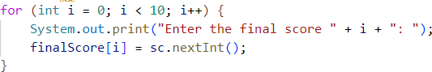
    - Using a loop, display all the contents of the elements from the finalScore array

    - Compile and run the program. Match the results of the running programs that you have created according to the following display
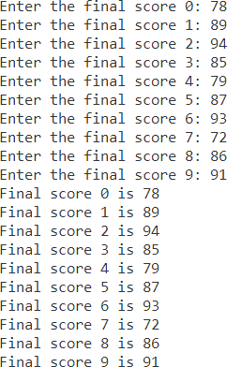
    - Commit and push the changes to GitHub.

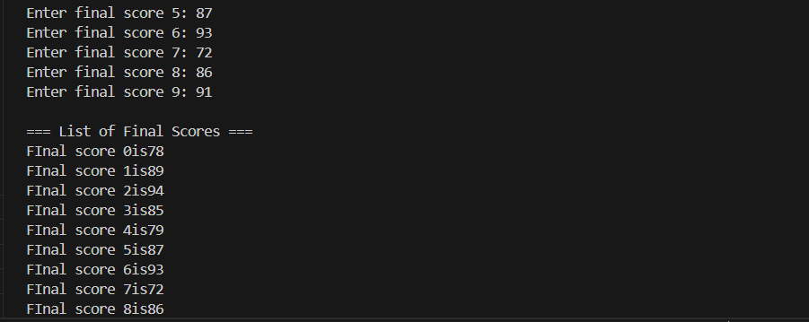

Questions!
- Change the statement in step 5 to be like this
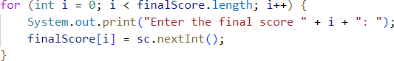
Run the program. Have there been any changes? How can it be like that?

So the program will eror because input change to sc that’s why the program will be eror.

- Apa yang dimaksud dengan kondisi i < finalScore.length?
Repeat the loop as long as the variable i less than the length of the array final score.
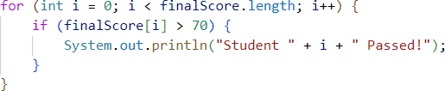
- Change the statement in step 6 to be like this, so that the program only displays the grades of students who passed, students who have a score > 70
Run the program and describe the flow of the program!
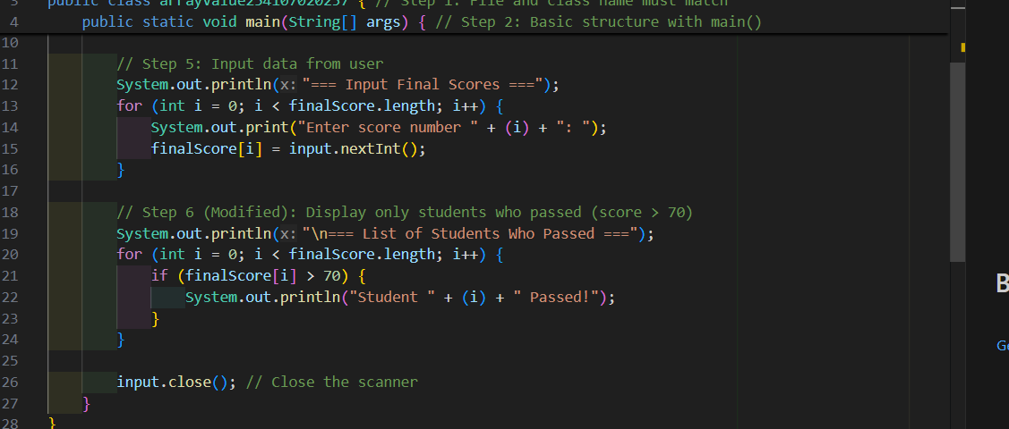
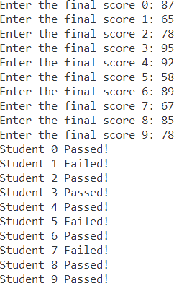
- Modify the program so that it displays all students, and mark which one passed, and which did not!
- Commit and push the changes to GitHub.

Experiment 3: Perform Arithmetic Operations on Array Elements Experiment Time: 75 minutes
This experiment is done to add array elements. The program will accept input of 10 student scores. Then the program will display the average score of 10 students.
    - Open a text editor, create a Java file then save it with the name arrayAverageScoreXX. (XX=student ID number)

    - Write the basic structure of the Java programming language which contains the main()
function
    - Add the Scanner library and make a Scanner declaration for input purposes
    - Create an array of integer types with the name score with a capacity of 10. Then declare the variables total and average
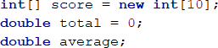
    - Using a loop, create an input to fill in the score array element
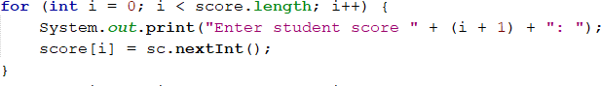
    - Using a loop, calculate the total number of scores.
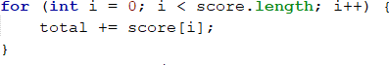
    - Calculate the average value by dividing total by the number of elements of score
    - Compile and run the program. Match the results of the running programs that you have created according to the following display
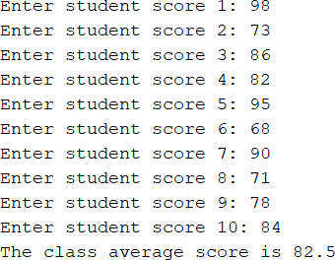
    - Commit and push the changes to GitHub

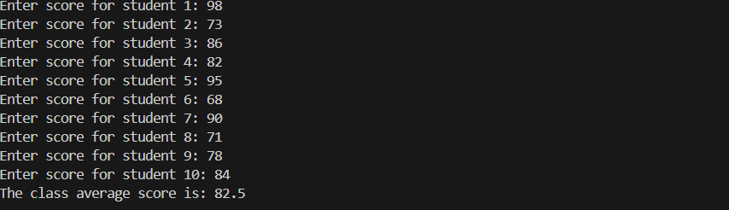

Questions!
- Modify the program in Experiment 3 so that the program can display the number of students who passed, students who have a score greater than 70 (>70)
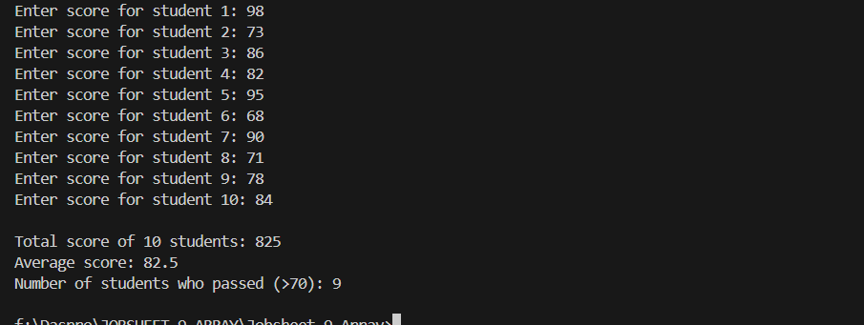
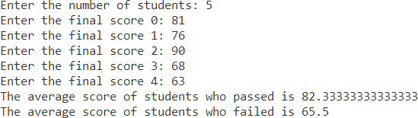
- Modify the program in Experiment 3 so that it can produce output like the following display
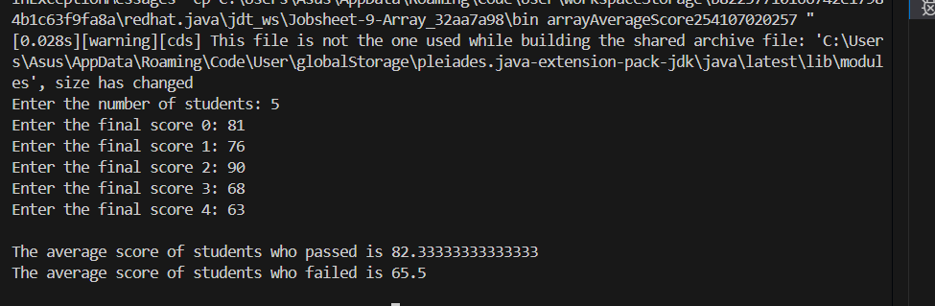
- Commit and push the changes to GitHub

Experiment 4: Searching Experiment Time: 45 minutes
    - Open a text editor, create a Java file then save it with the name linearSearchXX. (XX=student ID number)
    - Add the following code
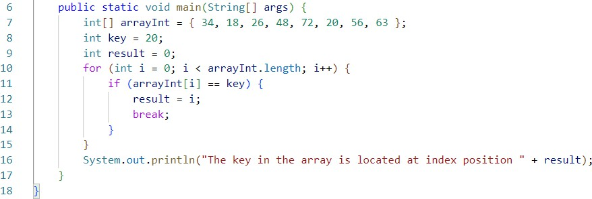
    - Compile and run the program. Match the results of the running programs that you have created according to the following display
    - Commit and push the changes to GitHub

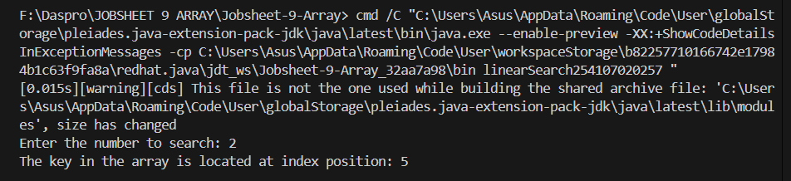

Questions!
- Explain the meaning of the break; statement on line 13 of the program code in Experiment 4.
The break statement it used to immediately stop the for loop once the number being searched(key) is found in the array.
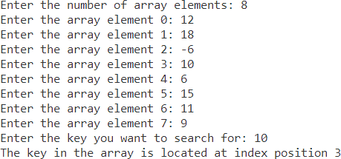
- Modify the program code in experiment 4 so that the program can receive input in the form of the number of array elements, the contents of the array, and the key you want to search for. Then, print to the screen the index of the element positions of the searched key. Example of program results:
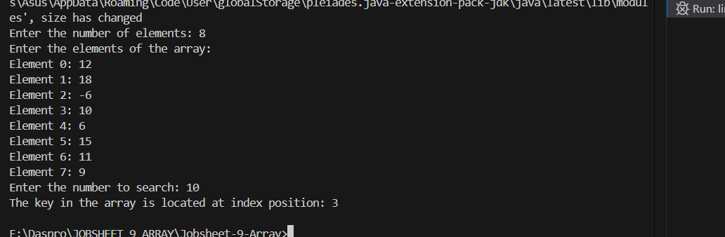
- Modify the program in experiment 4 so that the program will give the message "key not found" if the key is not in the array. Example of program results:

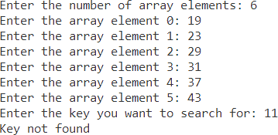
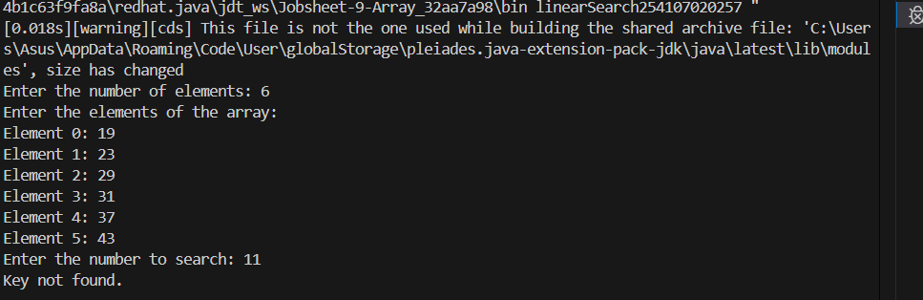

Assignment
- You are asked to create a program that can store and manage student grades. The grades are integers. The program must provide features for:
  - entering the number of student grades to be entered,
  - entering each student's grade,
  - calculating the average grade,
  - displaying the highest and lowest grades, and

  - displaying all grades entered.
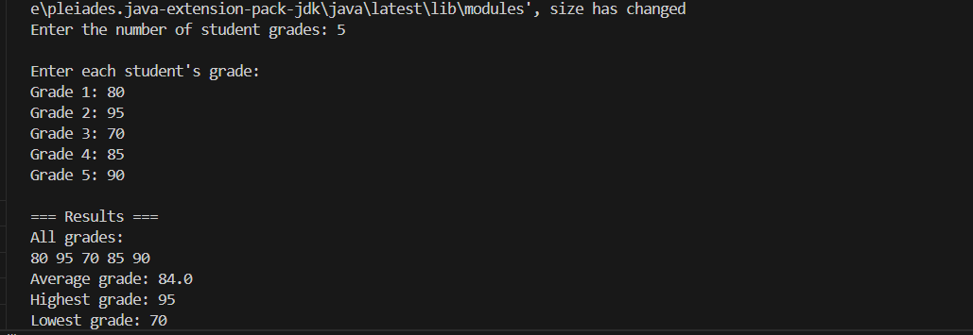
- Create a program that can manage food and beverage orders at a cafe. The program will allow users to enter orders, calculate the total cost of the order, and display a list of the orders that have been placed.
  - Input:
- number of orders (input by the user).
- name of the food/drink and the price for each order (input by the user).
  - Process:
- store the order data in a one-dimensional array for the order names; and a separate one-dimensional array for the prices.
- calculate the total cost of all orders entered.
- display a list of orders that have been entered along with the total cost.
  - Output:
- list of orders and the total cost of all orders.
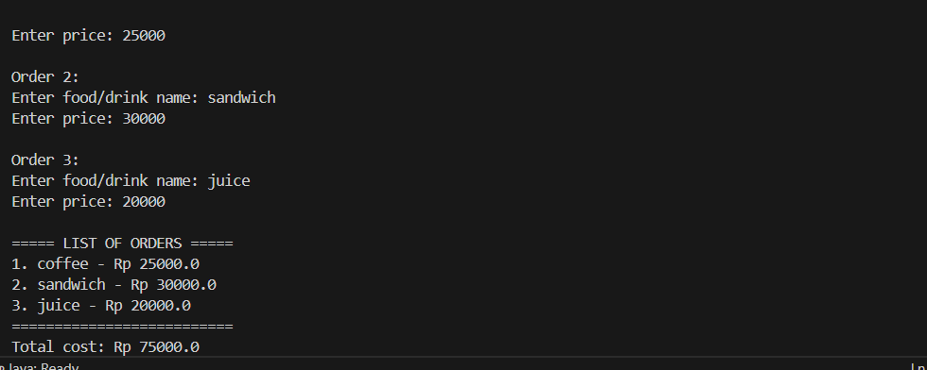
- Continuing with the example of ordering food at a cafe, create a program that allows users to order food from the cafe's menu. The program must store a list of food items in an array and provide an option to search for the desired item using a linear search method.
  - Input:
- a predefined menu item in array form. The item names are initialized during the array declaration. For example:
String[] menu = {"Fried Rice", "Fried Noodles", "Toasted Bread", "Fried Potatoes", "Teh Tarik", "Cappuccino", "Chocolate Ice"};
- the name of the item to be searched for (user input).
- Process:
- the program searches for the item entered by the user using a linear search algorithm.
- if the item is found, the program informs the user that it is available. If not, the program informs the user that the item is not on the menu.
  - Output:
- display the search results to the user.
